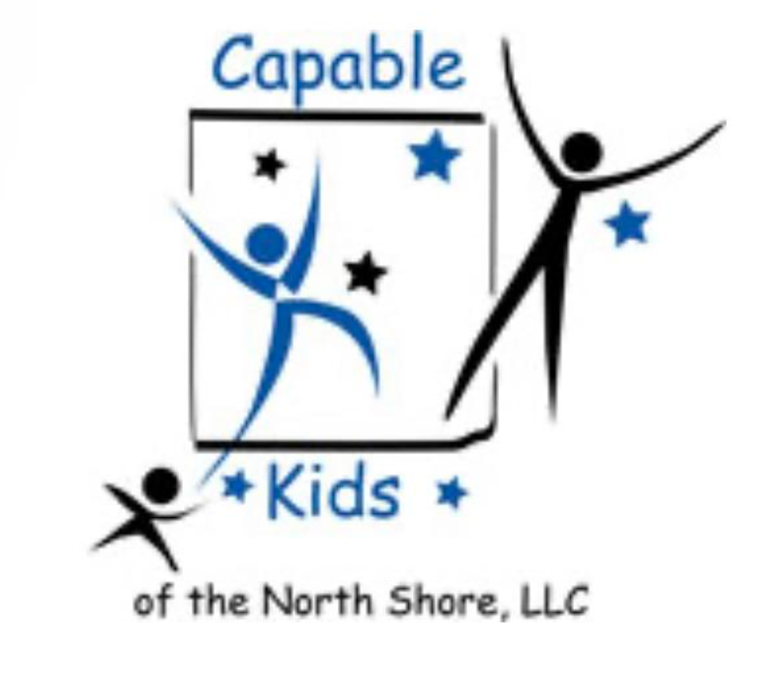Capable Kids of the North Shore

Victoria Abrams-Kelly, OTR/L

Sheila Poteshman, OTR/L

900 Skokie Blvd Suite 218

Northbrook, IL 60062

(847) 242-1587

[capablekidsinfo@gmail.com](mailto:capablekidsinfo@gmail.com)

Fax #: 224 203-5869

**FINANCIAL POLICY**

Thank you for choosing Capable Kids of the North Shore, LLC for your therapy needs. This is an agreement between Sheila Poteshman, OTR/L and you for payment of services provided. By signing this agreement, you agree to pay for all services provided to you or your family member for whom you are legally responsible.

**Insurance Verification and Billing**

The therapists at Capable Kids are in-network providers and will submit claims directly to Blue Cross/Blue Shield, PPO BCBS. Since Capable Kids therapists are considered out-of-network providers with other insurance carriers, submitting claims to these insurance companies will be considered on a case-by-case basis. Prior to your first therapy appointment, it is highly recommended that you check with your insurance plan, regardless of the carrier, to verify that occupational therapy services are covered. It is important to inquire about any information that is required, such as a doctor’s referral/prescription or a prior authorization. Please refer to the attached “Insurance Company Inquiry” form for further information.

Insurance Disclaimer: **You are responsible for contacting your insurance company to determine the coverage and benefits for our services.** It is important to note that information collected from the insurance companies is a quote and not a guarantee of payment. Benefits, if any, will be assessed by your insurance plan. Upon receipt, claims are subject to eligibility and based on plan provisions and limitations in effect at the time of services rendered. By signing this document, you agree to assign to Capable Kids all health care benefits to which you are entitled under your policy of insurance and authorize to the extent permitted by law, payment of those benefits directly to the therapist at Capable Kids.

**General Billing and Payment Policies:**

You will be provided with a monthly statement, which will include all unpaid balances deemed to be your responsibility. Once insurance has processed any submitted claims/sessions, the remaining balance (including deductibles and copays) is your responsibility and will be charged to the credit card on file (unless alternate form of payment is specified). Payment is due upon rectifying your monthly statement. A late fee of $25 will be charged on all unpaid balances 30 days from the date of your monthly statement.

I have read, understood, and agree to the Capable Kids Financial Policy as described above and understand that the Capable Kid therapist may refuse treatment if I do not remain current in payments for therapy services.

_______________________________

Parent/guardian name

________________________________ ____________________

Parent/guardian signature Date