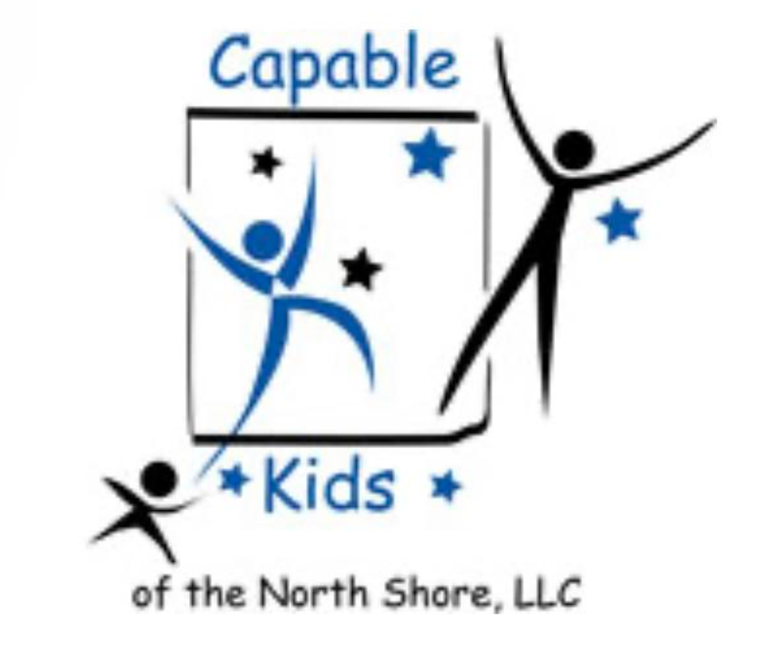Capable Kids of the North Shore

Victoria Abrams-Kelly, OTR/L

Sheila Poteshman, OTR/L

900 Skokie Blvd Suite 218

Northbrook, IL 60062

(847) 242-1587

[capablekidsinfo@gmail.com](mailto:capablekidsinfo@gmail.com)

Fax #: 224 203-5869

**NOTICE OF PRIVACY PRACTICES - Capable Kids of the North Shore LLC**

THIS NOTICE DESCRIBES HOW MEDICAL INFORMATION ABOUT YOU MAY BE USED AND DISCLOSED AND HOW YOU CAN GET ACCESS TO THIS INFORMATION.

Capable Kids of the North Shore LLC is required by law to maintain the privacy of all medical information within its organization; provide this notice of privacy practices to all clients; inform clients of our legal obligations; and advise clients of additional rights concerning their medical information. We must follow the privacy practices contained in this notice from its effective date of January 1, 2007, and continue to do so until this notice is changed or replaced. We reserve the right to change our privacy practices and the terms of this notice at any time, provided applicable law permits the changes. Any changes made in these privacy practices will be effective for all information that is maintained including information created or received before the changes were made. All clients will be notified of any changes by receiving a new notice of privacy practices.

USES AND DISCLOSURES OF MEDICAL INFORMATION

**TREATMENT:** Your information may be disclosed to a doctor or hospital that asks for it to provide treatment.

**PAYMENT:** Your medical information may be used or disclosed to pay claims for services provided by Capable Kids of the North Shore LLC.

**PERSONAL REPRESENTATIVE:** Your information may be disclosed to a family member, friend, therapist, teacher, or other person to help with treatment but only if you agree we may do so.

**RESEARCH:** Your medical information may be used or disclosed for research purposes in limited situations.

**COURT OR ADMINISTRATIVE ORDER:** Medical information may be disclosed in response to a court or administrative order, subpoena, discovery request, or other lawful process, under certain circumstances.

INDIVIDUAL RIGHTS

**AUTHORIZATIONS:** You may provide written authorization to use your medical information or to disclose it to anyone for any purpose. Unless you give written authorization, we cannot use or disclose your medical information for any reason except those described in this notice. You have the right to look at or get copies of your information. You have the right to request restrictions on or disclosure of your information. We are not required to agree to these additional requests, but if in agreement, we will honor the agreement, except in an emergency. Any requests must be in writing.

QUESTIONS AND COMPLAINTS

If you are concerned that your privacy rights have been violated, or you disagree with a decision made about access to your information, or in response to a request made to amend or restrict the use or disclosure of your information, you may complain to us using the contact information below. You may also submit a written complaint to the U.S. Department of Health and Human Services. We support your right to protect the privacy of your medical information. There will be no retaliation in any way if you choose to file a complaint with us or with the U.S. Department of Health and Human Services.

Signature ______________________________________ Date ________________