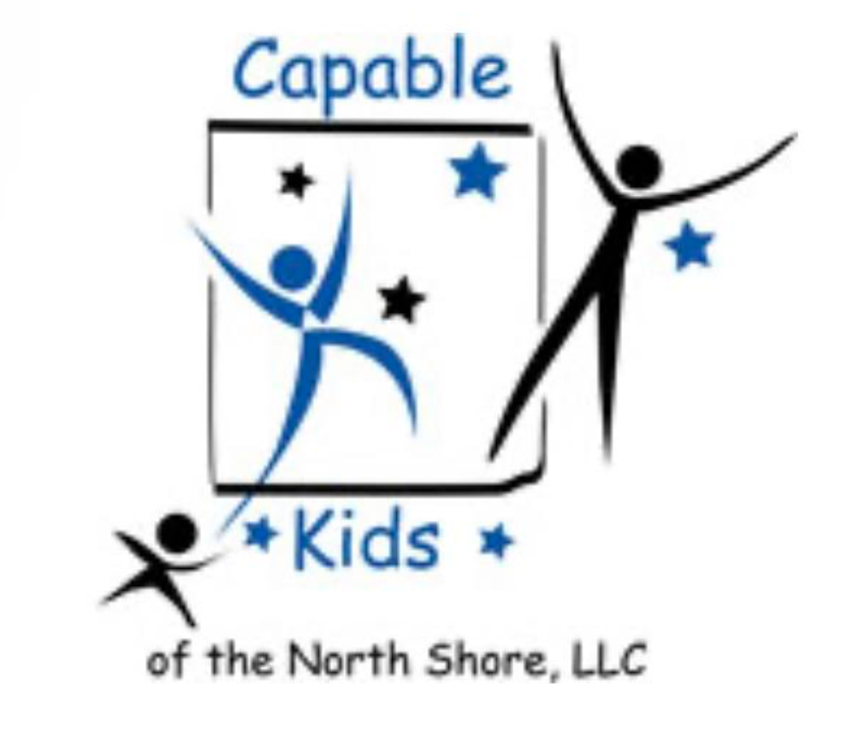Capable Kids of the North Shore

Victoria Abrams-Kelly, OTR/L

Sheila Poteshman, OTR/L

900 Skokie Blvd Suite 218

Northbrook, IL 60062

(847) 242-1587

[capablekidsinfo@gmail.com](mailto:capablekidsinfo@gmail.com)

Fax #: 224 203-5869

**PARENTAL RELEASE FOR**

**OCCUPATIONAL THERAPY SERVICES**

I ____________________________ give ______________________ permission to contact the following professionals and/or facilities regarding my child, _____________________________. Communication may be either verbal (i.e., phone conversation) or written (i.e., medical records, reports, etc.).

Pediatrician _______________________ Medical Specialist __________________________

Address _______________________ Address __________________________

Phone _______________________ Phone ___________________________

Email ________________________ Email __________________________

School _______________________ Therapist ___________________________

Contact _______________________ Address ___________________________

Address _______________________ ___________________________

_______________________ Phone ___________________________

Phone _______________________

Email ________________________ Email ___________________________

____________________________________ _________________________________________

Signature (parent/guardian) Date