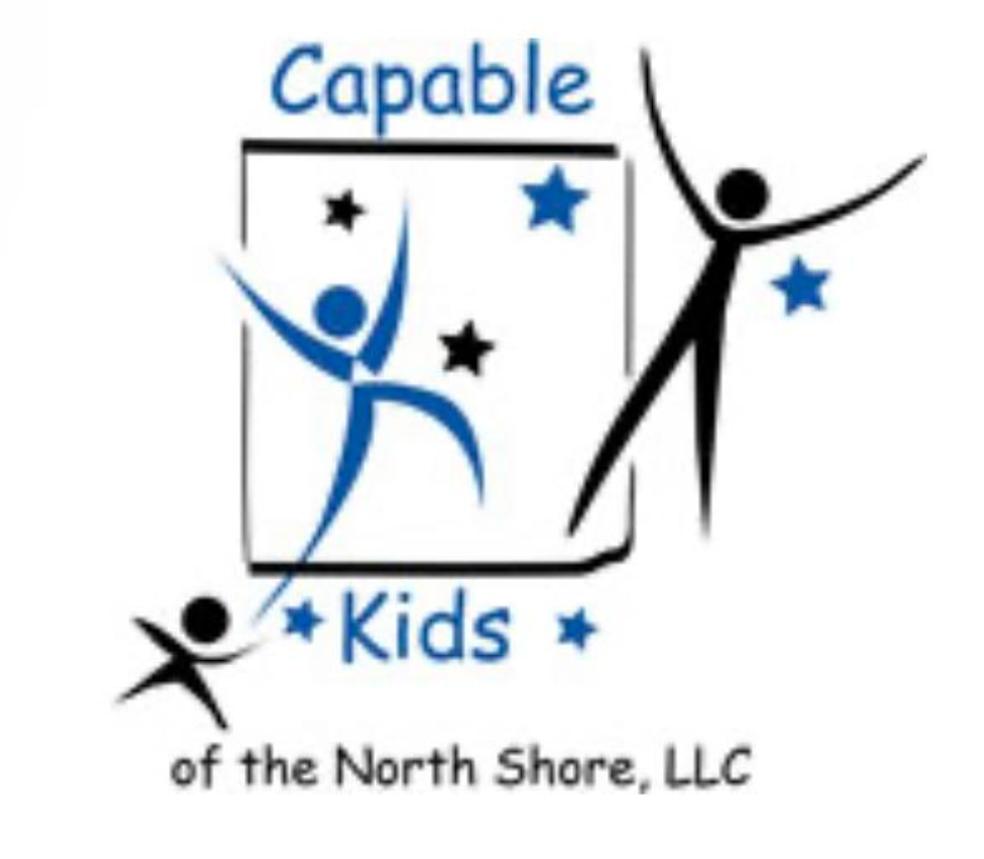
Capable Kids of the North Shore
Victoria Abrams-Kelly, OTR/L
Sheila Poteshman, OTR/L
900 Skokie Blvd Suite 218
Northbrook, IL 60062
(847) 242-1587
capablekidsinfo@gmail.com
Fax #: 224 203-5869

PARENTAL RELEASE FOR
OCCUPATIONAL THERAPY SERVICES
I ____________________________ give ______________________ permission to contact the following professionals and/or facilities regarding my child, _____________________________. Communication may be either verbal (i.e., phone conversation) or written (i.e., medical records, reports, etc.).
Pediatrician _______________________ Medical Specialist __________________________
Address _______________________ Address __________________________
Phone _______________________ Phone ___________________________
Email ________________________ Email __________________________

School _______________________ Therapist ___________________________
Contact _______________________ Address ___________________________
Address _______________________ ___________________________
_______________________ Phone ___________________________
Phone _______________________
Email ________________________ Email ___________________________

____________________________________ _________________________________________
Signature (parent/guardian) Date

