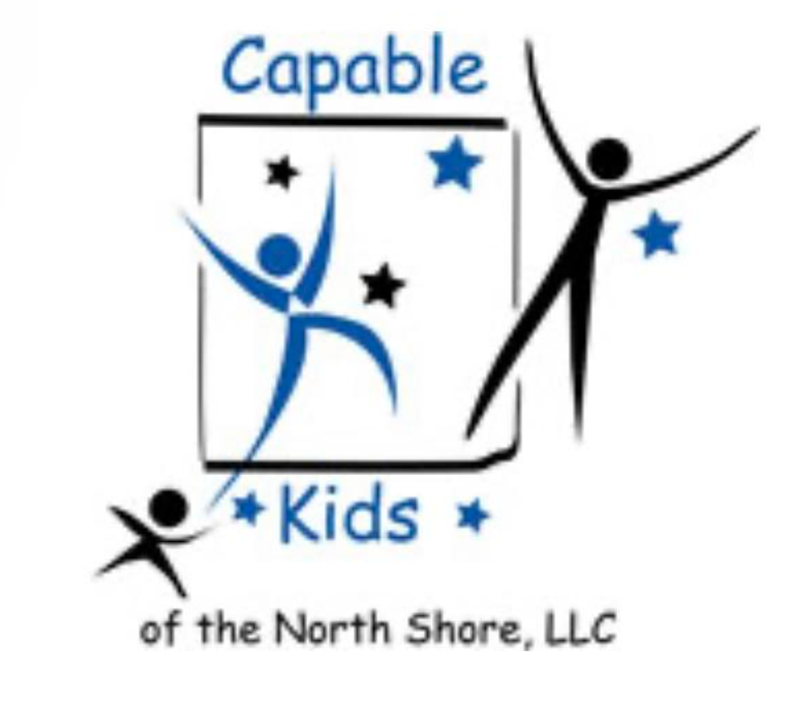Capable Kids of the North Shore

Victoria Abrams-Kelly, OTR/L

900 Skokie Blvd Suite 218

Northbrook, IL 60062

(847) 242-1587

[capablekidsinfo@gmail.com](mailto:capablekidsinfo@gmail.com)

**PAYMENT RECORD**

Month: ________________

| NAME | DATE | PAYMENT TYPE | AMOUNT |
| --- | --- | --- | --- |
|  |  |  |  |
|  |  |  |  |
|  |  |  |  |
|  |  |  |  |
|  |  |  |  |
|  |  |  |  |
|  |  |  |  |
|  |  |  |  |
|  |  |  |  |
|  |  |  |  |
|  |  |  |  |
|  |  |  |  |
|  |  |  |  |
|  |  |  |  |
|  |  |  |  |
|  |  |  |  |