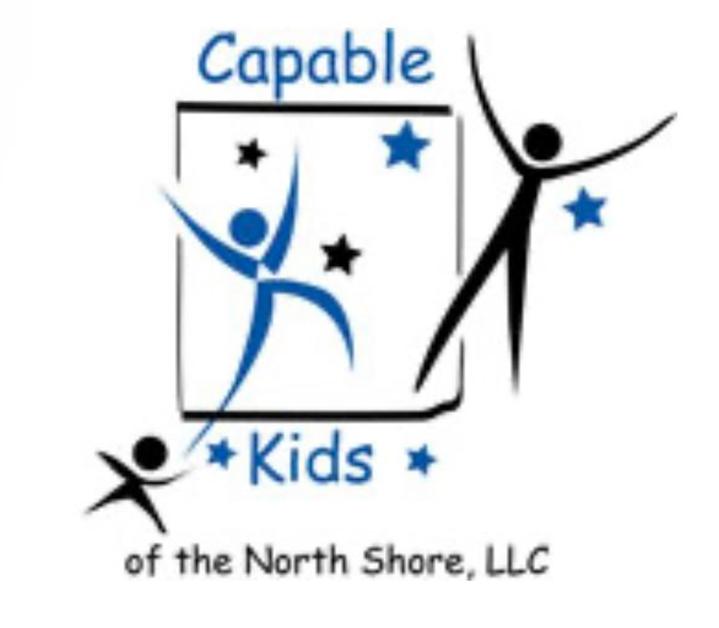
Capable Kids of the North Shore
Victoria Abrams-Kelly, OTR/L
900 Skokie Blvd Suite 218
Northbrook, IL 60062
(847) 242-1587
capablekidsinfo@gmail.com

PAYMENT RECORD

Month: ________________
NAME | DATE | PAYMENT TYPE | AMOUNT

