Capable Kids of the North Shore

Victoria Abrams-Kelly, OTR/L

Sheila Poteshman, OTR/L

900 Skokie Blvd Suite 218

Northbrook, IL 60062

(847) 242-1587

[capablekidsinfo@gmail.com](mailto:capablekidsinfo@gmail.com)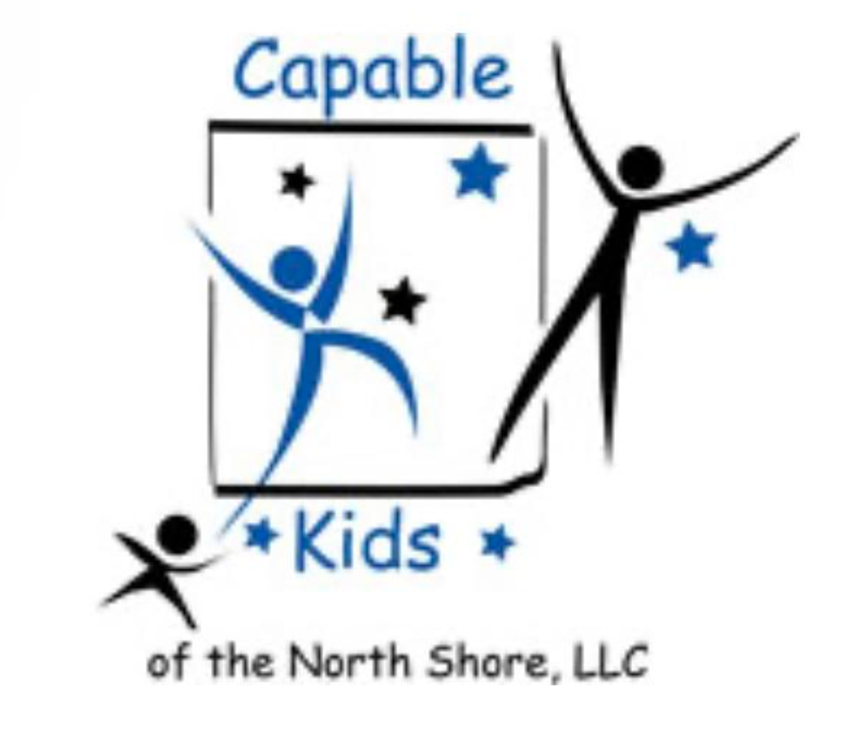

Fax #: 224 203-5869

**PHYSICIAN REFERRAL FOR**

**OCCUPATIONAL THERAPY**

Child’s name: _____________________________________________________________________

Parents: __________________________________ Birth Date: ______________________________

Address: __________________________________ Phone: ________________________________

Diagnosis and/or Description of Disability: ________________________________________________________________________________________________________________________________________________________________

Medications: ______________________________________________________________________

Precautions: ______________________________________________________________________

Referral for Occupational Therapy:

[☐](https://coolsymbol.com/copy/Ballot_Box_Symbol_%E2%98%90)Evaluation [☐](https://coolsymbol.com/copy/Ballot_Box_Symbol_%E2%98%90)Treatment

Physician’ Name: ________________________________ Phone: ___________________________

Physician’s Signature: ____________________________ Date: _____________________________