Capable Kids of the North Shore
Victoria Abrams-Kelly, OTR/L
Sheila Poteshman, OTR/L
900 Skokie Blvd Suite 218
Northbrook, IL 60062
(847) 242-1587
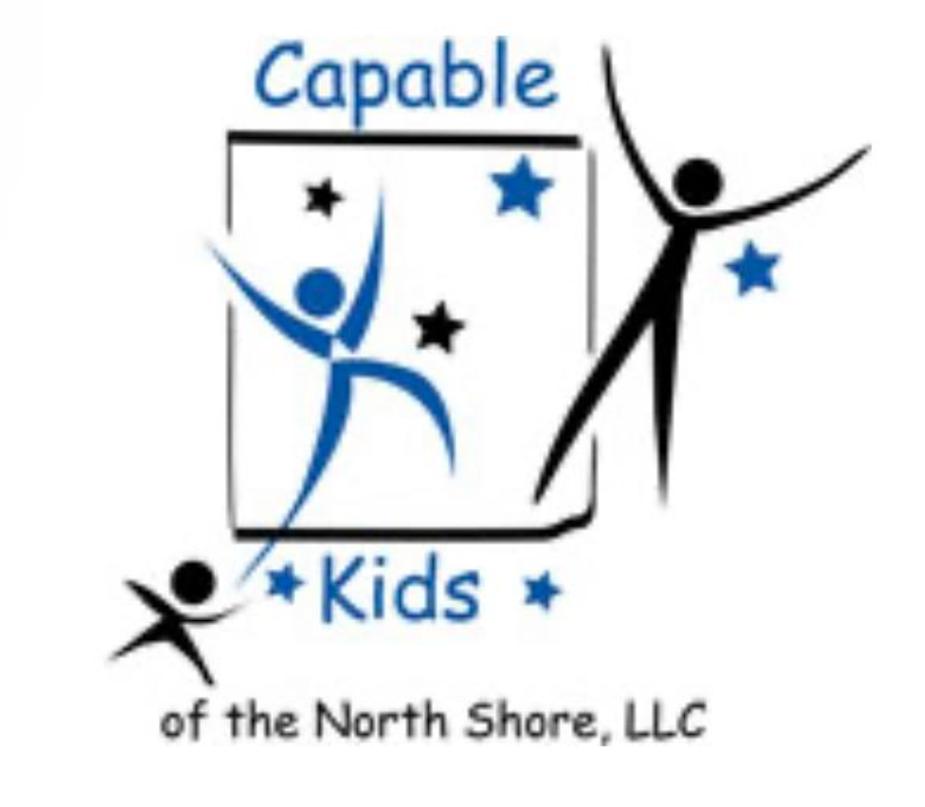
capablekidsinfo@gmail.com
Fax #: 224 203-5869

PHYSICIAN REFERRAL FOR
OCCUPATIONAL THERAPY
Child’s name: _____________________________________________________________________
Parents: __________________________________ Birth Date: ______________________________
Address: __________________________________ Phone: ________________________________

Diagnosis and/or Description of Disability: ________________________________________________________________________________________________________________________________________________________________
Medications: ______________________________________________________________________
Precautions: ______________________________________________________________________

Referral for Occupational Therapy:
☐Evaluation ☐Treatment

Physician’ Name: ________________________________ Phone: ___________________________

Physician’s Signature: ____________________________ Date: _____________________________

