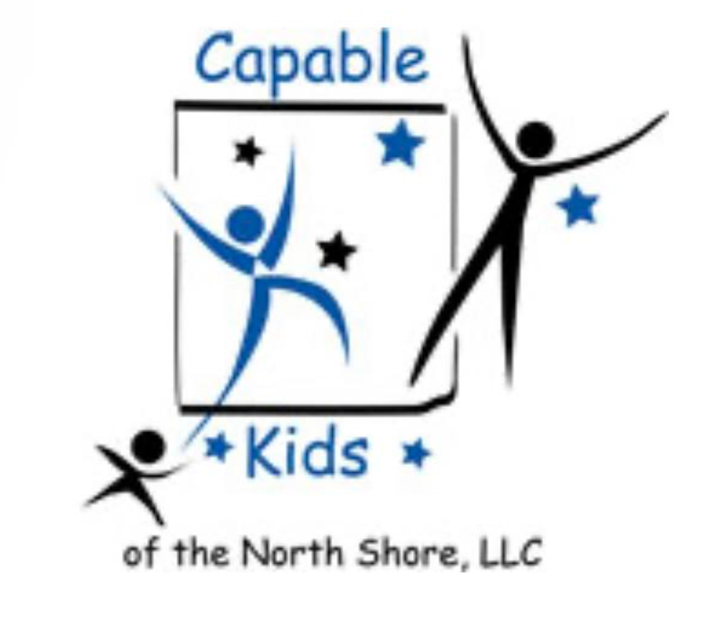Capable Kids of the North Shore

Victoria Abrams-Kelly, OTR/L

Sheila Poteshman, OTR/L

900 Skokie Blvd Suite 218

Northbrook, IL 60062

(847) 242-1587

[capablekidsinfo@gmail.com](mailto:capablekidsinfo@gmail.com)

Fax #: 224 203-5869

**QUESTIONS TO ASK YOUR INSURANCE CARRIER BEFORE YOUR APPOINTMENT:**

Your Primary Insurance is: ________________

Secondary (if applicable): ________________

Member ID#: ________________________________

Member Services Phone #: ___________________________________________

Date you Called: ____________________ Who you spoke to: ______________

1. Verify with your insurance company if there would be coverage for the services your child needs: Occupational therapy CPT Code 97530

2. Do I have a co-payment or is there a percentage of the bill I will be responsible for?

3. Does my plan require a deductible be paid for the calendar year before the coverage begins?

4. Does my child have an out-of- pocket maximum that I pay per calendar year?

5. Does my insurance plan cover only a limited number of sessions for each calendar year?

6. Is there a requirement that I get a prior authorization and/or a referral before I see a clinician? Yes_____ No_____ If yes, who do I contact? ____________________

Phone: ___________________________ Email: _____________________________